C Code Documentation: Circuit Testing Program

Overview
This C program accepts user input in binary format (0 or 1) and tests basic digital circuits: AND, OR, and NOR. The program employs enum for circuit types and switch statements to handle logic operations based on user input.

Features
- Accepts binary input (0 or 1) for two variables.
- Tests and displays the output for the following circuits:
  - AND
  - OR
  - NOR
- Utilizes enum for defining circuit types.
- Uses switch statements for circuit operation logic.

Code Structure

Includes and Definitions
c
Copy code
#include <stdio.h>

enum CircuitType {
AND,
OR,
NOR
};
- #include <stdio.h>: Standard input-output library for using printf and scanf.
- enum CircuitType: Defines an enumeration for the circuit types: AND, OR, NOR.

Function Prototypes
void testCircuit(enum CircuitType type, int input1, int input2);
- testCircuit: Function to evaluate the circuit based on the specified type and inputs.

Main Function
int main() {
int input1, input2;
int circuitChoice;

printf("Enter first binary input (0 or 1): ");
scanf("%d", &input1);
printf("Enter second binary input (0 or 1): ");
scanf("%d", &input2);

printf("Choose circuit type:\n");
printf("0: AND\n1: OR\n2: NOR\n");
scanf("%d", &circuitChoice);

if (input1 < 0 || input1 > 1 || input2 < 0 || input2 > 1) {
printf("Invalid inputs! Please enter 0 or 1.\n");
return 1;
}

testCircuit((enum CircuitType)circuitChoice, input1, input2);

return 0;
}
- Prompts the user for two binary inputs and the desired circuit type.
- Validates the inputs to ensure they are binary (0 or 1).
- Calls testCircuit with the selected circuit type and inputs.

Circuit Testing Function
void testCircuit(enum CircuitType type, int input1, int input2) {
int output;

switch (type) {
case AND:
output = input1 && input2;
printf("AND(%d, %d) = %d\n", input1, input2, output);
break;
case OR:
output = input1 || input2;
printf("OR(%d, %d) = %d\n", input1, input2, output);
break;
case NOR:
output = !(input1 || input2);
printf("NOR(%d, %d) = %d\n", input1, input2, output);
break;
default:
printf("Invalid circuit type selected.\n");
break;
}
}
- Evaluates the circuit based on the selected type using a switch statement.
- Calculates and prints the output for the selected circuit.

Usage Instructions
- Compile the code using a C compiler:
bash
Copy code
gcc -o circuit_tester circuit_tester.c
- Run the compiled program:
bash
Copy code
./circuit_tester
- Follow the prompts to enter binary inputs and select the circuit type.

Example
Enter first binary input (0 or 1): 1
Enter second binary input (0 or 1): 0
Choose circuit type:
0: AND
1: OR
2: NOR
1
OR(1, 0) = 1

Error Handling
- The program checks for valid binary inputs (0 or 1) and will terminate with an error message if invalid input is detected.

Logic Gate Tables (for Inputs and Outputs resp.):

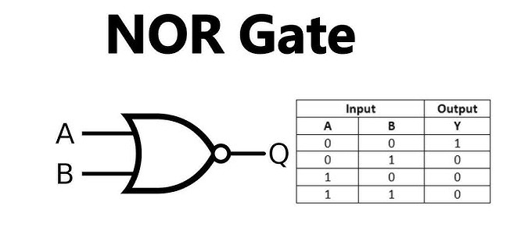

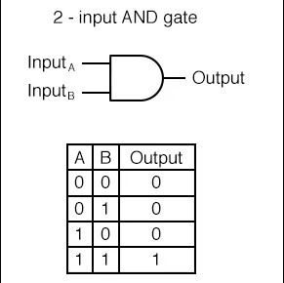

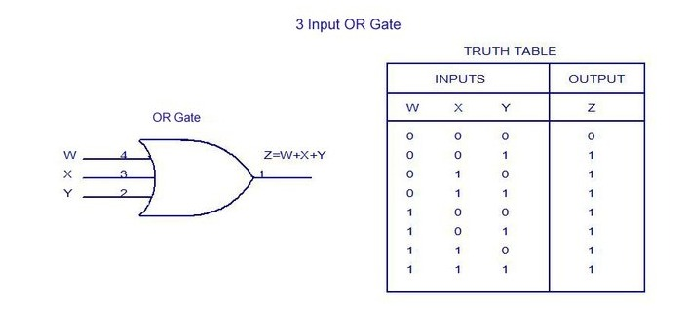

Conclusion
This simple C program demonstrates basic digital logic operations using binary inputs. It showcases the use of enum and switch statements for a clear and organized code structure, making it a useful tool for learning about circuit logic in programming.

